**DAILY ONLINE ACTIVITIES SUMMARY**

|  |  |  |  |  |  |  |  |  |
| --- | --- | --- | --- | --- | --- | --- | --- | --- |
| **Date:** | **16/06/2020** | | | | | **Name:** | **RITIKA KULKARNI** | |
| **Sem& Sec** | **4thSEM. & ‘B’ SEC.** | | | | | **USN:** | **4AL19CS403** | |
| **Online Test Summary** | | | | | | | | |
| **Subject** | | **COMPLEX ANALYSIS,PROBABILITY & STATISTICAL METHODS** | | | | | | |
| **Max. Marks** | | **30** | | **Score** | | | **22** | |
| **Certification Course Summary** | | | | | | | | |
| **Course** | **Introduction of cloud** | | | | | | | |
| **Certificate Provider** | | | **Cognitive class** | | **Duration** | | | **5 Hrs.** |
| **Coding Challenges** | | | | | | | | |
| **Problem Statement:**   1. **Write a C Program to perform the operations on Triply Linked List (TLL)** | | | | | | | | |
| **Status: Executed** | | | | | | | | |
| **Uploaded the report in Github** | | | | | **Yes** | | | |
| **If yes Repository name** | | | | | <https://github.com/ritikakulkarni> | | | |
| **Uploaded the report in slack** | | | | | **Yes** | | | |

**Online Test Summary: 18CS41 test was scheduled from 3:00 pm to 3:40 pm. The portion for the IA was 1st module there were 15 questions and the time assigned was 40 minutes the questions were mcq type. But there was an issue with the time mentioned, so that we got only 30mins. to finish the test. The time was not sufficient to answer all the questions. There were 15 questions of 2 marks respectively.**

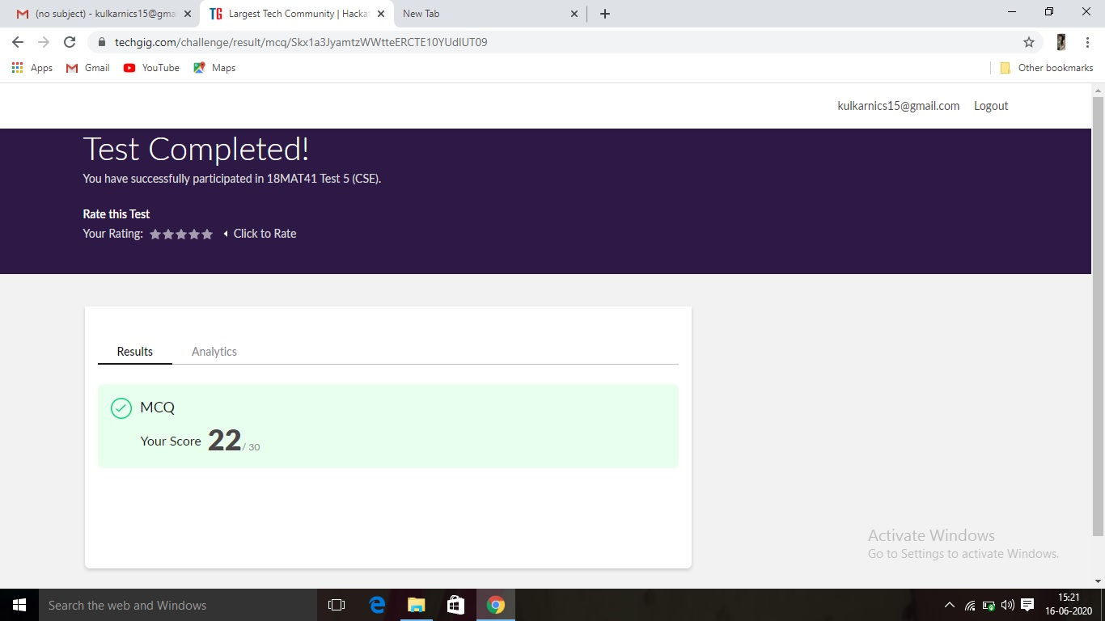

**Certification Course Summary: Today, I went through the Introduction of cloud and definition.**

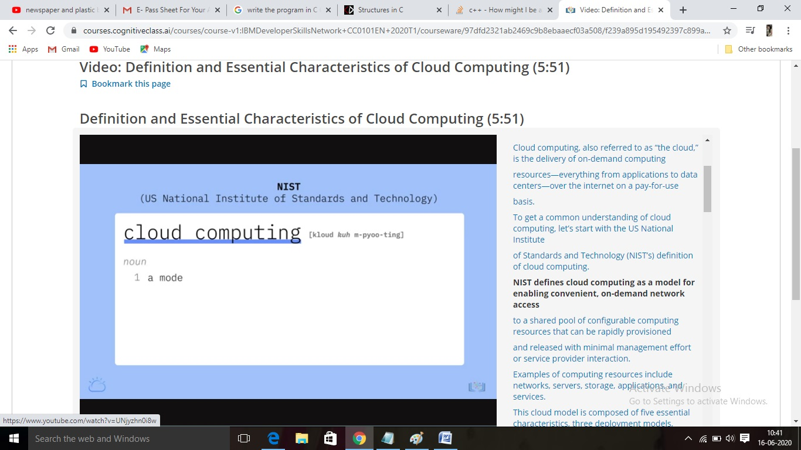

**Online Coding Summary:Online Coding Summary​: Online coding Summary: Today I received one program from Prof. Venkatesh bhat CSE Dept. The program is mentioned above(pg.01). to my GitHub repository and I’ve shared the snapshot below.**

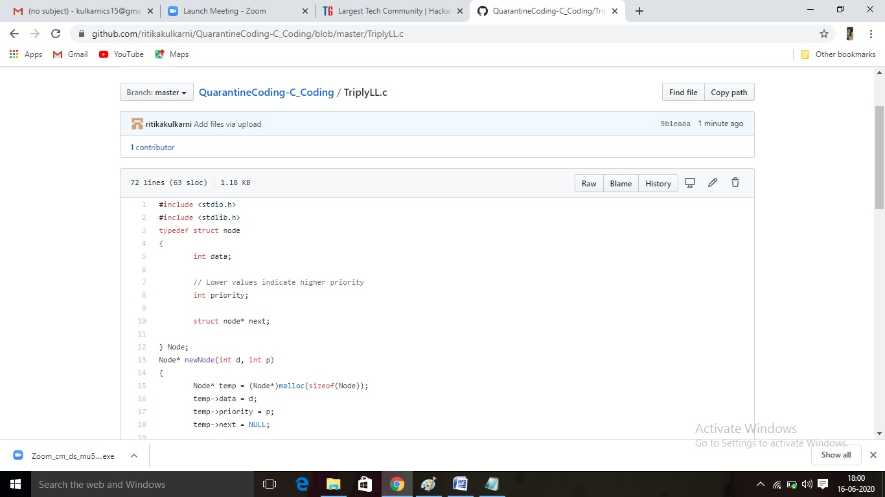

**Thank you.**